August 12, 2018



TITLE: FRONT-END SOLUTIONS FOR INTERNET OF THINGS APPLICATION.

enterprise information systems

class assignment

Anshika Banerjee

10372825

MSc. Information Systems with Computing (Jan 2018)

|  |  |
| --- | --- |
| MODULE NAME | Enterprise Information System |
| MODULE NUMBER | B9IS104 |
| LECTURER NAME | Paul Laird |
| STUDENT NAME | Anshika Banerjee |
| STUDENT NUMBER | 10372528 |
| COURSE NAME | MSc. Information System with Computing |
| ENTERPRISE INFORMATION SYSTEM APPLICATION TOPIC COVERED. | Oauth Authentication and Web Services |
| LINK TO GITHUB REPOSITORY | <https://github.com/anshikabanerjee/EIS-10372528-CA2> |
| LINK TO PWA HOSTED ON A OPEN SOURCE SERVER | <https://cantabrigian-peak.000webhostapp.com/index.html> |

Table of Contents

Abstract 3

1. Introduction 4

2. Aim 5

3. Objectives 5

4. Design 6

5. Methodology 9

5.2 APIs Used 11

5.2 Development 11

6. Relevance 12

7. Limitations 13

8. Obstacles 14

9. Future Scope 15

10. Learning Outcomes 16

11. Screenshots 17

12. Conclusion 23

13. References 24

# Abstract

The artefact is a one-point solution for IOT applications. It provides a front-end outlet to which any IOT application who wants to display and interpret data can use. The artefact is meant for the user to correctly understand the data generated by the devices/ sensors. The artefact will do certain amount of analysis with the live data. This function will be achieved via Google Analytics API. The data will be obtained from ThingsSpeak.com. The website is an opensource platform for uploading IOT data. And for the purpose of the stimulation of the PWA, we will pull data from this website onto our PWA. The PWA will encapsulate all web services within itself. The login into this Web App will be through OAuth via a Google account.

# Introduction

This artefact facilities front end solutions for all IOT (Internet of Things) applications. The data generated by the IOT device or sensors will be streamed live into our Progressive Web Application and displayed in a user-friendly manner.

The Progressive Web Application or (PWA) is a hybrid of a regular web pages (or websites) and a mobile application. This new application model attempts to combine features offered by most modern browsers with the benefits of mobile experience.

The need for the artefact is dire as stated “The number of IOT devices increased 31% year-over-year to 8.4 billion in 2017(*Große internationale Allianz gegen Cyber-Attacken*, 2016) and it is estimated that there will be 30 billion devices by 2020. The global market value of IoT is projected to reach $7.1 trillion by 2020.” (Nordrum, 2016).

OAuth Authentication technique will be used to make the web app secure. For OAuth to work the user needs to own a google account. In this manner the OAuth authentication will confirm the legitimacy of the user and approve their access. Thus, this artefact will be secure form invalid users.

# Aim

The main aim of the project is as follows:

1. To fulfil the criteria of the Enterprise Information Systems Class Assignment.
2. To have a secure system.
3. To provide Web Services to IOT devices.
4. To make a system which is easy to be used by every user.

# Objectives

1. To fulfil the criteria of the Enterprise Information Systems Class Assignment, the artefact incorporates Oauth authentication and uses APIs from different platforms in the form of web services.
2. The Artefact itself is an attempt to provide web services. It can be used with any IOT device and facilitate its frontend for it.
3. The Artefact uses Oauth to provide attention services. It authenticates the users. And thus, renders the safe use of the application.
4. The PWA is designed such that the users will find it easy to navigate through the site. It provided with a simple GUI.

# Design

The artefact is built as a PWA. According to a study done by (‘Progressive web apps: key benefits, statistics, use cases’, 2017) PWAs are the best innovation which capacitates the benefits of both a mobile app and a website.

The PWA pulls data from ThingsSpeak.com. Things Speak open source platform provides an API setup to pull the live data from their servers to our PWA Setup. A specific channel will be built to handle this data. A channel is setup between ThingsSpeak.com and our Artefact, the API controls the flow of data. The data streaming is attempted to be done live. This feature is be achieved with the help of the ThingsSpeak.com server and Kafka Server which is a server used for live data streaming. The data transfers take place in the following ways, parent site will generate a CSV, XML or JSON data file to be transported and displayed into the PWA. The generated file is transported to google sheets. Google sheets generates and performs analytical operations on it and this report is pulled into the PWA via Google Sheets APIs.

We have narrowed down to 3 specific channels from where we want to pull data from. The links to these channels has been provided in the Appendix. These three channels have very different and varied data. Once the artefact is built. The true usefulness of the PWA will be seen.

Google API will be used to display and work with that data. For example, Google Analytics and Google Graphs will be used. Once the data is in the Web App, we will run it through the Google Analytics API and get certain patterns.

OAuth Authentication techniques will be deployed on to this application to make it more secure. They say “Data is the new oil for our century.” And that is why we need to make sure the IOT data is made secure. OAuth will help in this area.

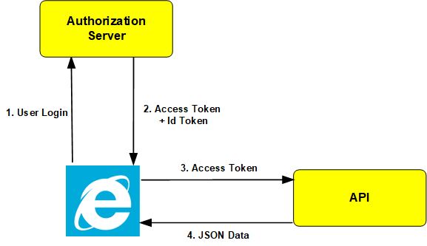

Figure: The Working of Oauth within the artefact.

The Authorization Server, the artefact is using the Google Authentication Services via a “Gmail.com” email address. As seen above in the diagram the Web browser sends the user login request to the Authorization server. This is done so by, the user entering their Gmail credentials. The username and passwords of the user are sent to the Google Authentication server to be verified. The server then sends the access tokens and Token Id back to the web browser if the user is successfully verified.

The access token obtained from the Authentication server is then sent to the API to retrieve data. Data in our artefact can be obtained in the form of JSON, XML and a CSV file format.

Thus, the above diagram depicts the way the Oauth service works. In this was the artefact is able to provide a secure service to the user of this application.

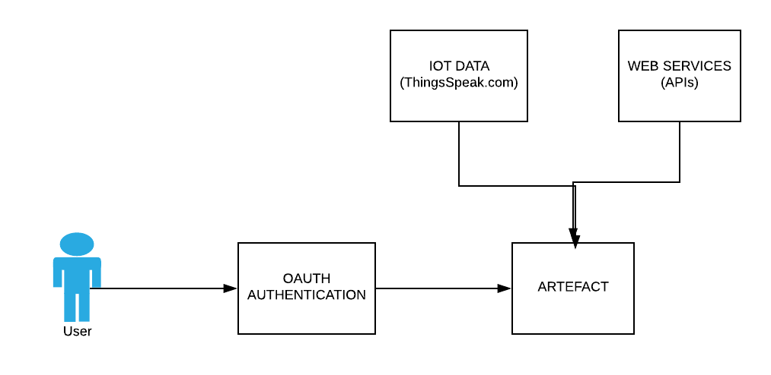

Figure: The flow of the artefact.

The above figure shows the flow of the proposed system. The applications or artefact will have an initial oauth authentication page which will allow the user to verify himself. The authentication can be done via a Google account. In the future scope of this application the authentication can be done via Facebook LinkedIn, GitHub.

The artefact is connected to the ThingsSpeak.com server and multiple Web Services. In the figure above how, the artefact is connected to the oauth Authentication information system and the different Web Services.

Together with all the above setup it provides web services to the user as a whole.

# Methodology

The development of the artefact was an individual effort. Thus, the Software Development method chosen to work on this project was the waterfall model.

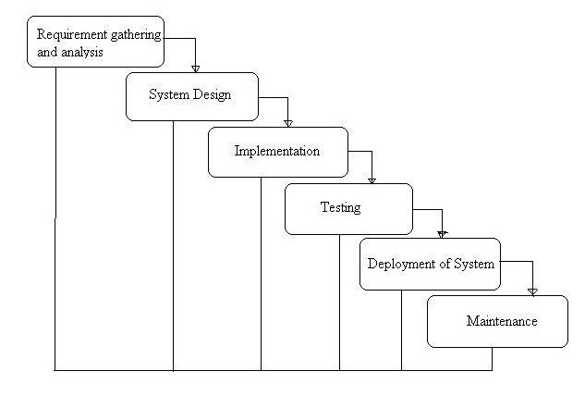

Figure: The Waterfall Model.

* It is a basic, straight-forward approach.
* It is easy to develop a plan for managing a Waterfall project since every stage has a starting point and an ending point.
* The early start to planning provides a good basis for designing components that integrate with external systems. Thus, while incorporating webservices. It proved to be very helpful.
* The cost of development and the feasibility of the project was resolved ahead of time.
* The detailed procedures were used to regulate every part of the process.
* The reliance on design, documentation reduced the stress from development and allowed more time to focus on the important stages of the Project.

While the development of the project all the aspects of the waterfall model were kept in mind and then implemented. Each stage was given ample time to complete and then reviewed, before proceeding into the next stage.

1. **Requirement Gathering**

This phase was heavily dominated with the learning of the Oauth and different Enterprise Information System Applications. The learning of the use of APIs within an application. How to work with APIs and how they are incorporated within a wen application. The research also concluded with the PWA. PWA emerged as the best way to portray todays application development. They are latest advancements in this field.

1. **System Design**

The PWA was designed with wireframes. Online open source platforms such as Draw.io and LucidCharts.com were used to aid this process.

1. **Implementation**

The development of the website took place of the IDE Visual Studio Code.

1. **Testing**

Peer to peer testing method was used to test the working model of the artefact. The peers within the class of MSc. Information System with Computing (Jan 2018) were asked to volunteer and test this artefact, and provide relevant feedback.

1. **Deployment of System**

Every working phase of the artefact was deployed on to GitHub.

1. **Maintenance**

Monitory checks are done on the code from time to time.

## 5.2 APIs Used

1. Google Maps API
2. YouTube Data API
3. Google Graph API
4. Things Speak API
5. Google Analytics API
6. Gmail API
7. Canvas Clock API

(Check Appendix for Screenshots)

## 5.2 Development

Languages Used:

1. HTML
2. JavaScript
3. PHP

Data Used:

1. JSON
2. XML
3. CSV

# Relevance

Every device is turning into a smart device that is, its evolving into an IOT Application. From self-driving cars to smart refrigerators, all the appliances we see today will be transmitting data and making our lives more data driven than ever before. Thus, we need to realize the importance for the visualization of data and interpretation of things.

All IOT applications generate tons of data. A Temperature sensor can send data every minute/hour. A pulse sensor can send data every second. Depending on the device the amount of data generated can vary. Big data is the outcome of this phenomena. Having a front end which is capable of interpreting the data ad letting users correctly decide what the generated data actually means. Interpreting data helps in forming patterns and leading to finding solutions.

This data needs to be displayed in a fashion, that is understood by the end user. GUI which is easy to comprehend and will be clear in rendering the information. The users are not over loaded with massive information about numerous things. They are only concerned with what is important and relevant to their field.

Security is the need of the hour. It’s a basic fundamental of any system. Since we are dealing with data. The site needs to be secure. Thus, Oauth is used to fulfil the requirement of security. With the help of Oauth the user authentication is done.

A PWA can work offline. Thus, if the server is down the user will still be able to access the PWA and view previous data. Once the server is up again, it will automatically refresh itself and update the records.

The application in a whole provides web Services to all IOT Applications.

# Limitations

* The artefact does not have a backend database.
* The artefact does not support multi-platform Sign in that is You can only authenticate yourself via google. At the moment there is no provision to sign in from Facebook or LinkedIn.
* There is no live streaming of data.
* Due to unavailability of Apache Kafka. There is no live streaming of data through the artefact. The initial proposal stated that, there will be a direct channel built between ThingsSpeak.com and the artefact. But after through research and R&D phases, it was found that it is not possible to do so without the presence of a live server.
* The website is hosted on the web on an open source web hosting server. Due to this its domain name is not verified by google. This raises security issues during oauth authentication process.
* Due to lack of time the UI is not polished well.
* Only the Google Oauth works. The Facebook, LinkedIn ones are not functional.

# Obstacles

* Difficulty in coding Oauth into the PWA. It is difficult to run the Facebook or LinkedIn Oauth sign ins.
* Unable to host it on server.
* Encountering Paid use of Servers.
* No Live server presents. Thus, no live streaming of data.
* Time constraints.
* Data Streaming issues.

# Future Scope

* The ability to host it to a proper web server. Which will allow live streaming of data.
* Adding Facebook and LinkedIn Sign Ins.
* Adding more features of the PWA.
* Adding more methods to work with data in the PWA.
* Adding a NoSQL database to handle the big data.

# Learning Outcomes

* Development of a PWA.
* Working and Implementation of Oauth authentication.
* The use of multiple Web Services. How to implement a web service into your application.
* In depth knowledge of an Application Enterprise Information System Technologies.
* Process and stages of Software Development.

# Screenshots

Google Credentials for Using different APIs.

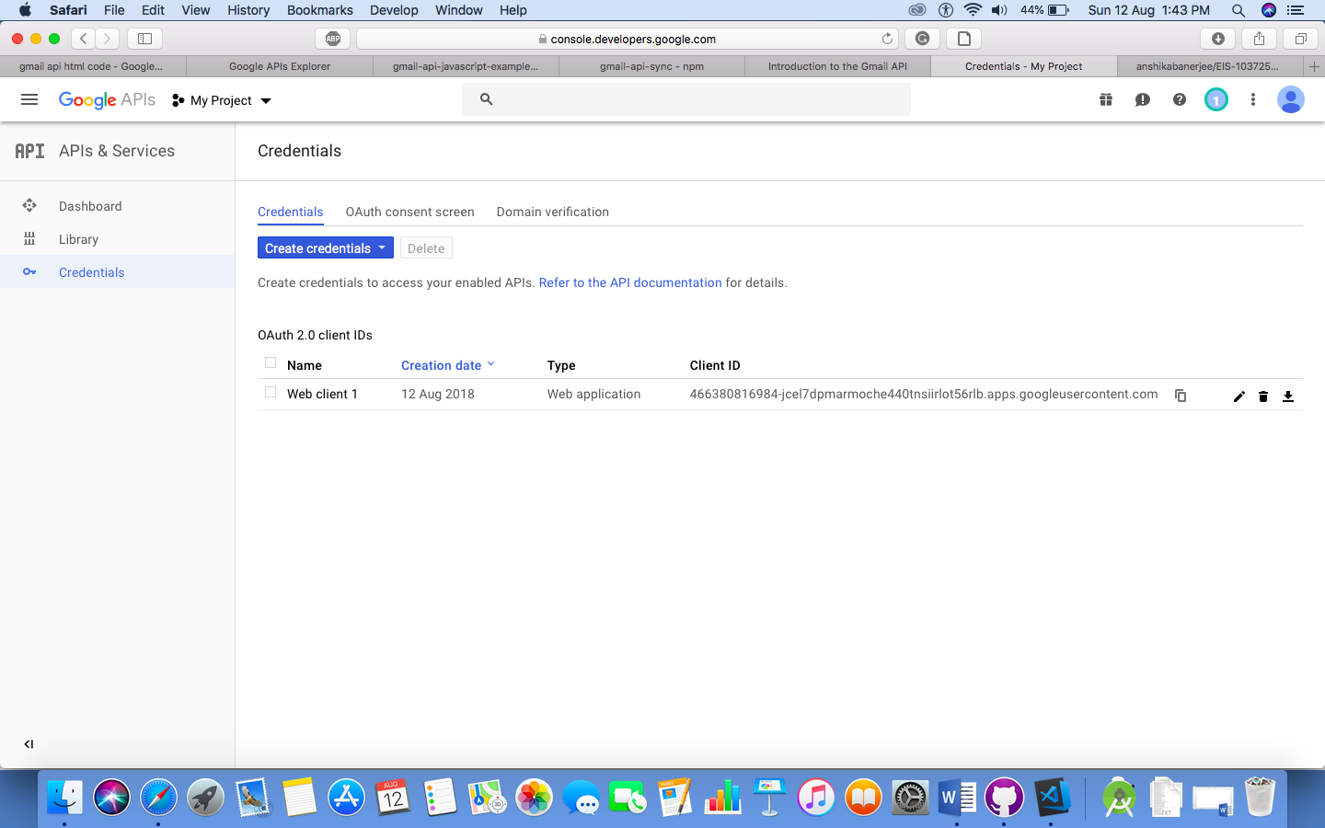

Oauth Sign In.

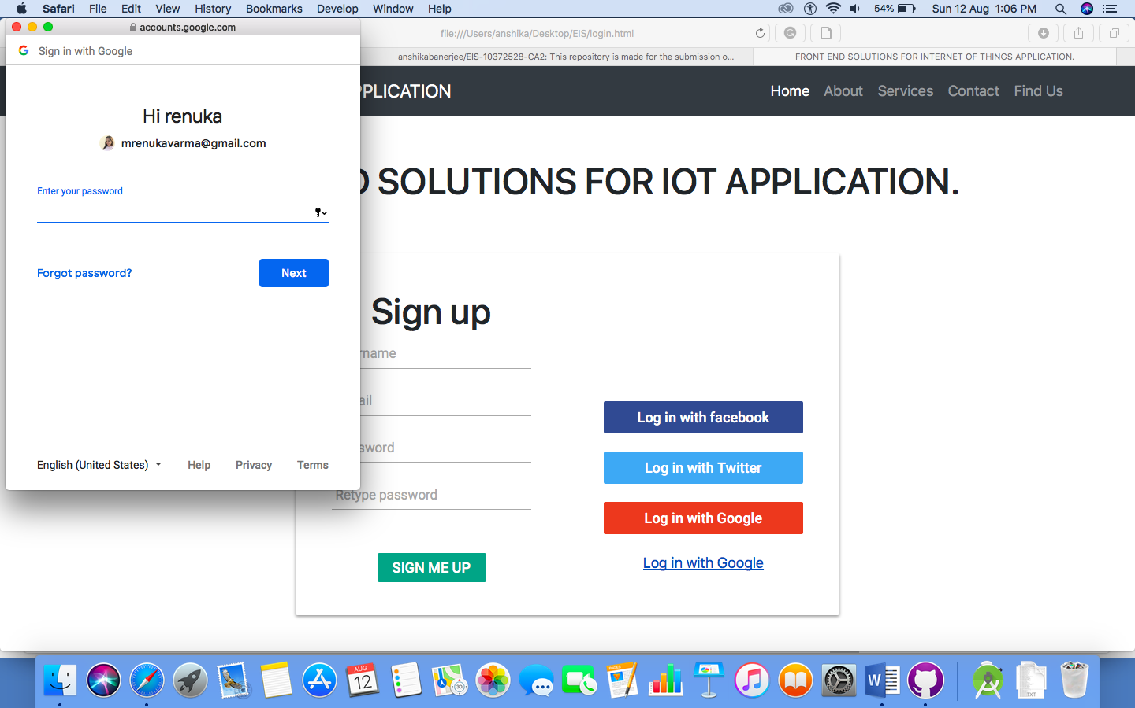

Oauth Sign In Page, Showing multiple Gmail Accounts.

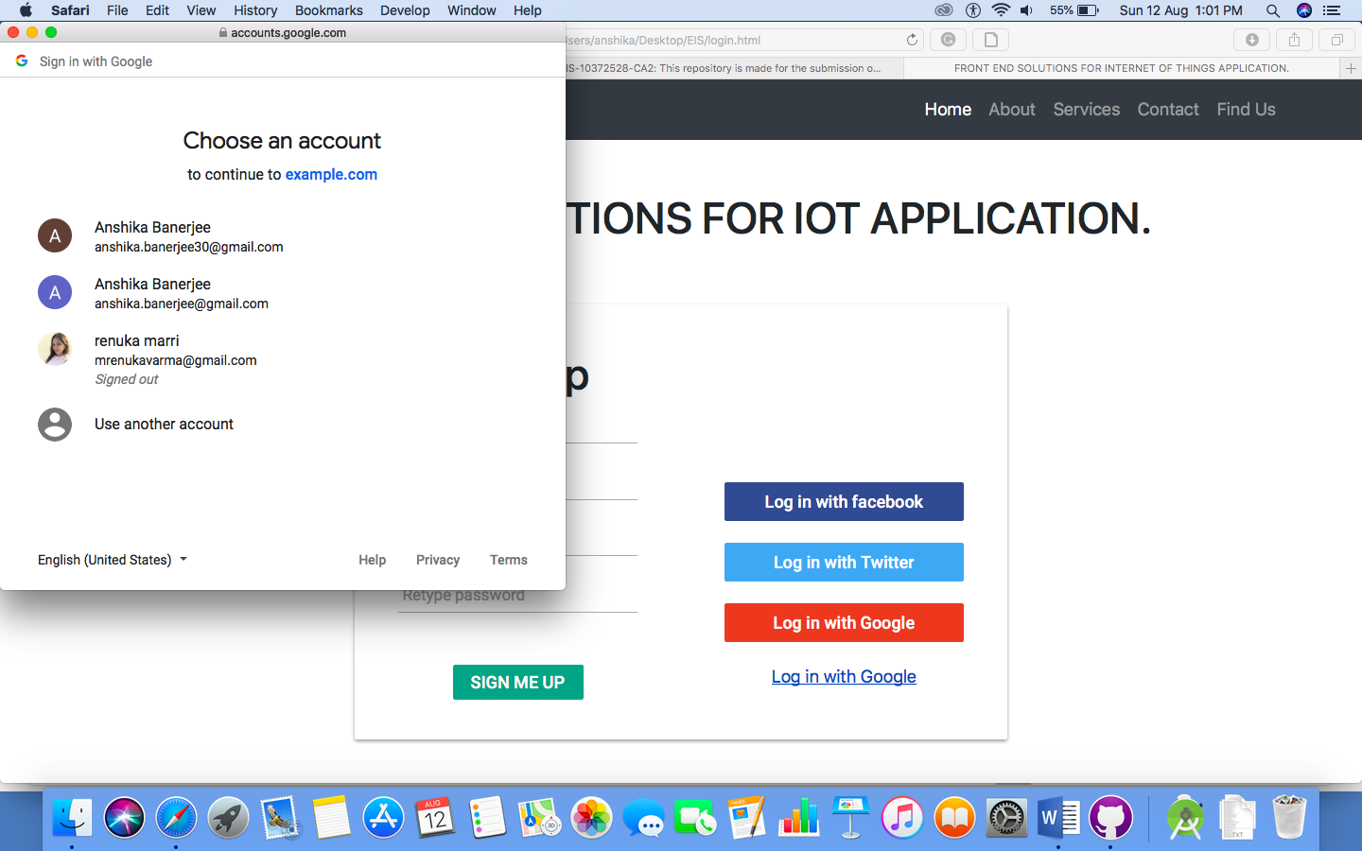

Things Speak .com Site Where data is being exported from to the PWA. (artefact)

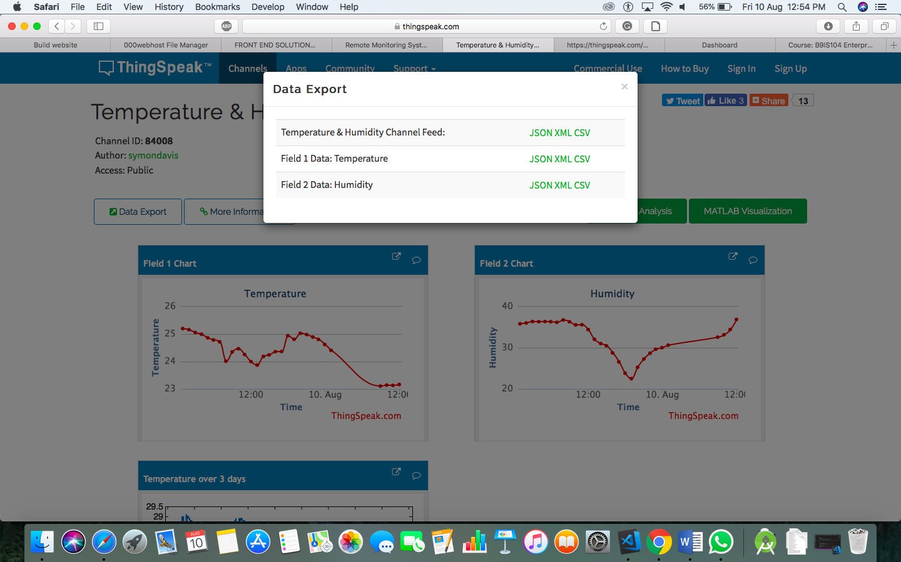

Landing page of the artefact

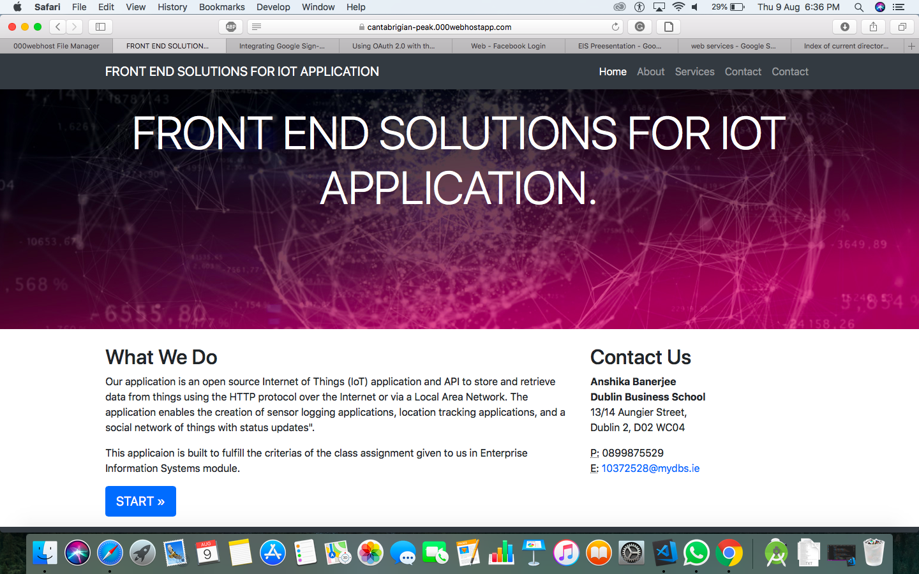

Open Source web server where the site is hosted.

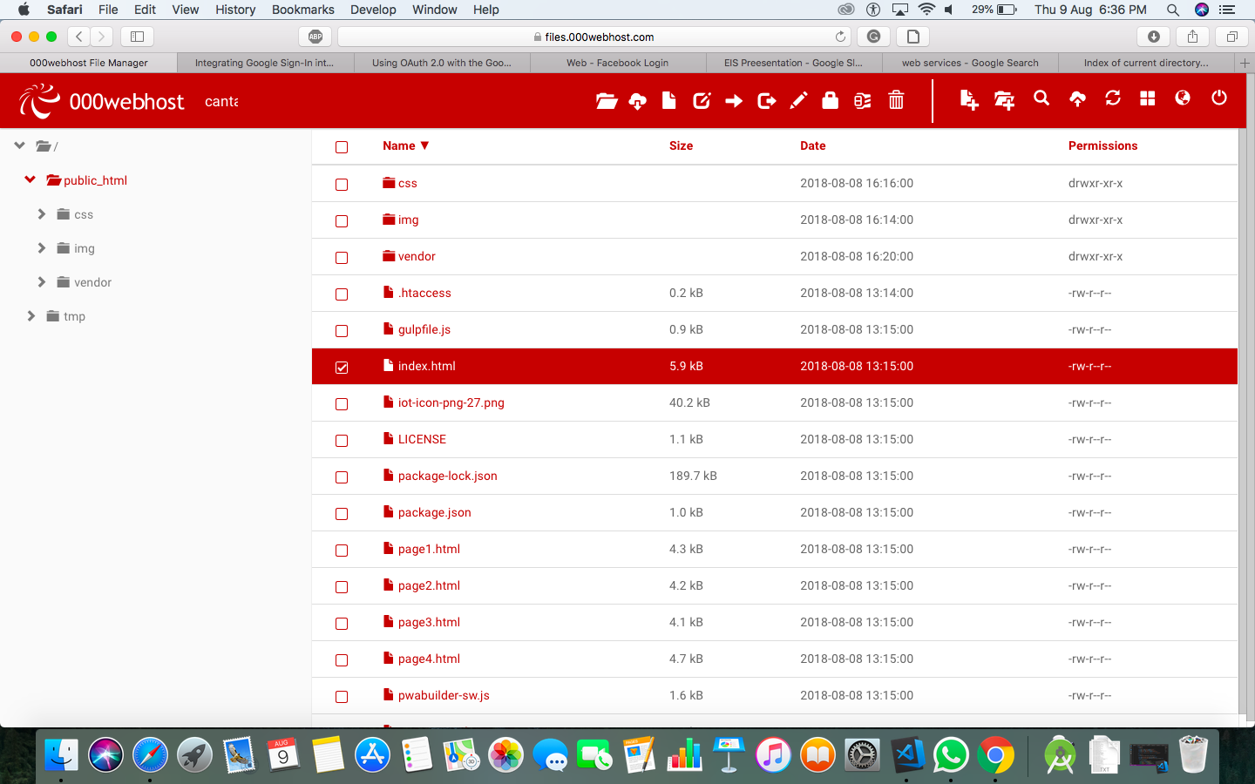

Screenshot of PWA working in Offline Mode.

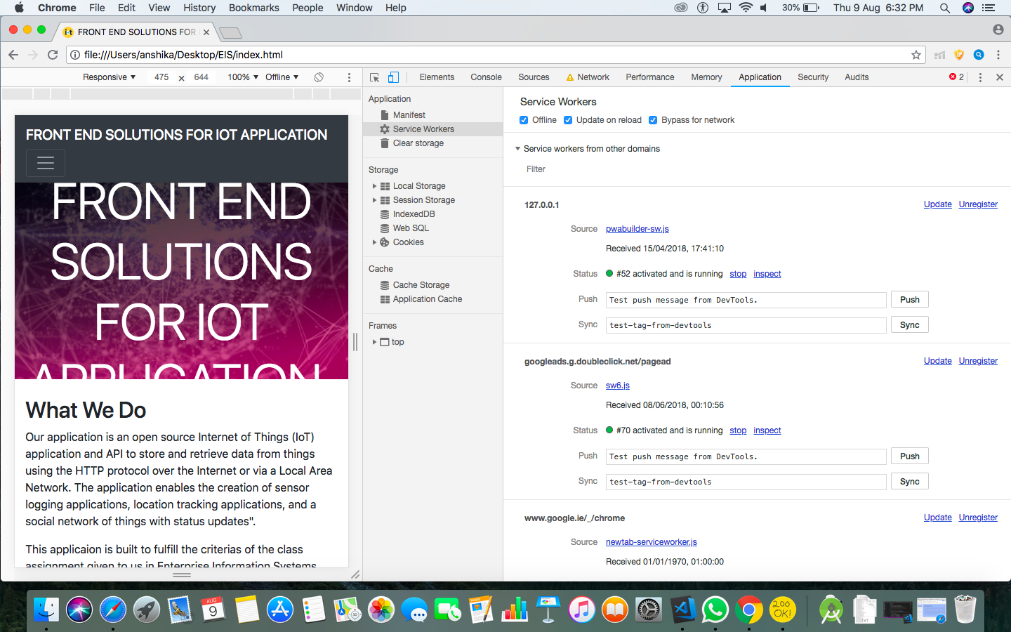

YouTude data API

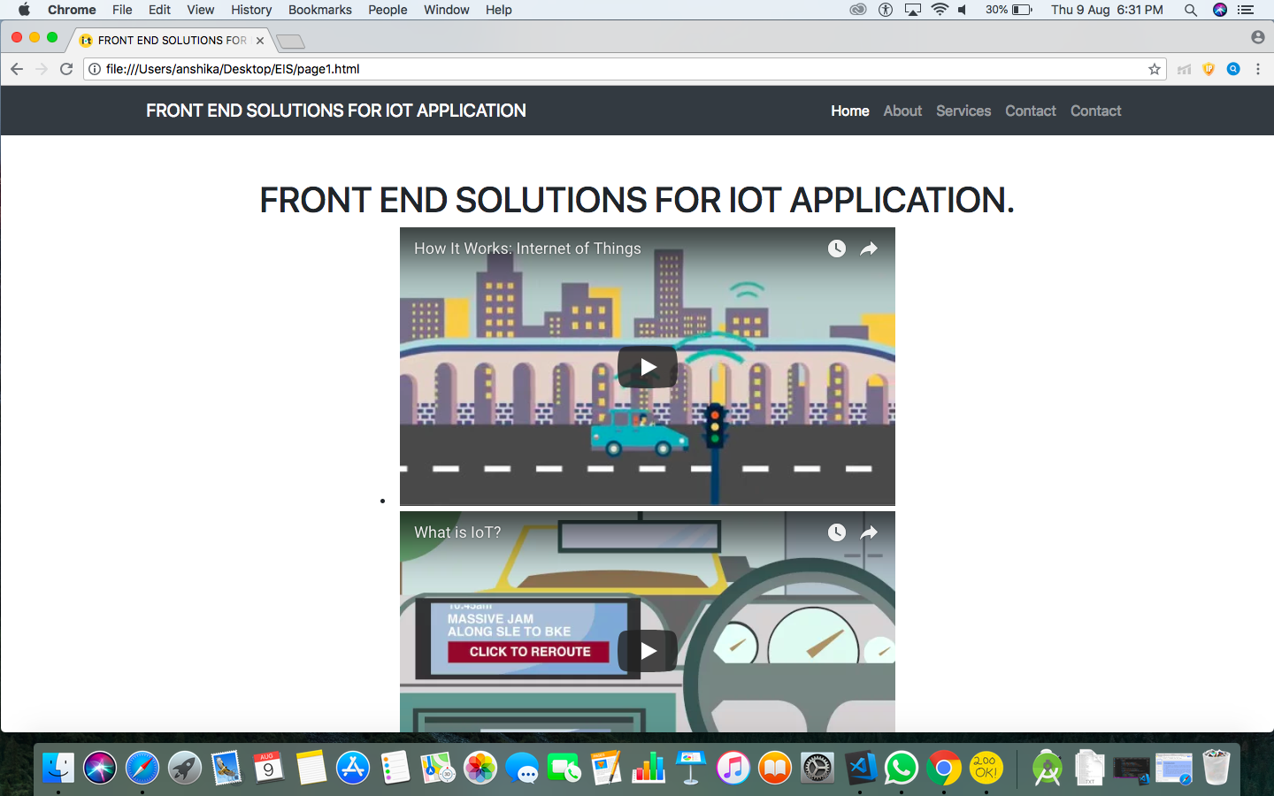

Oauth authentication page.

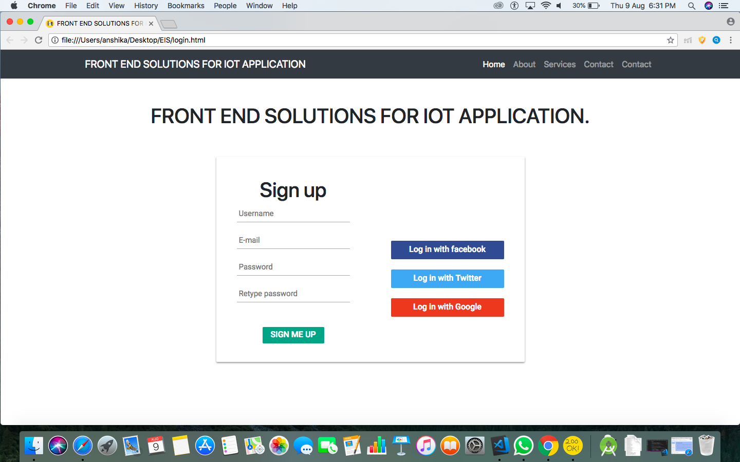

Google Maps API page

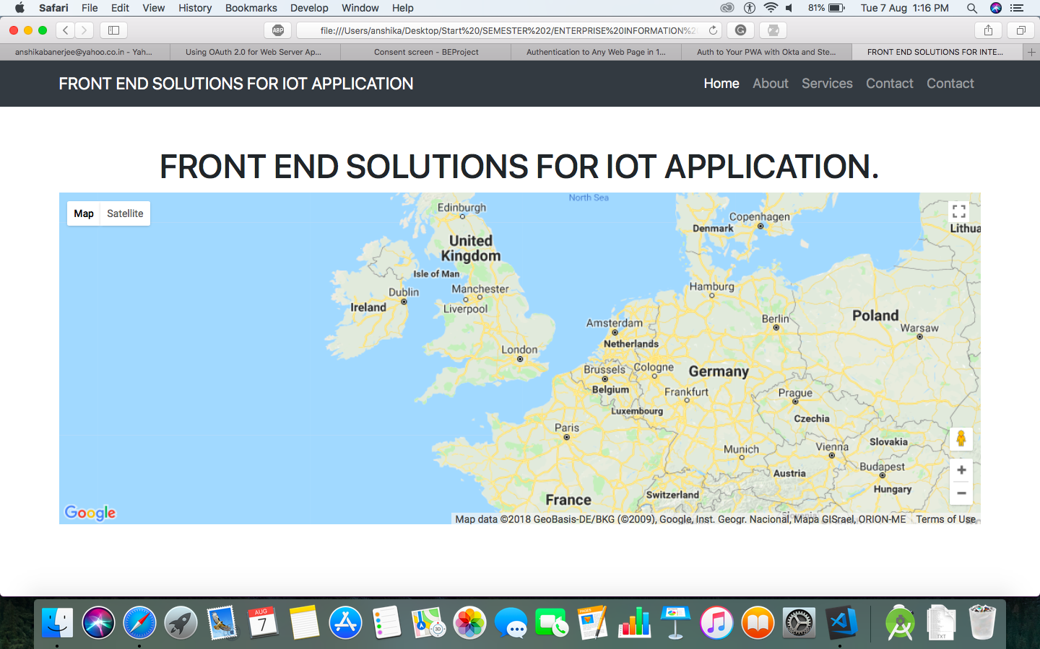

Clock API

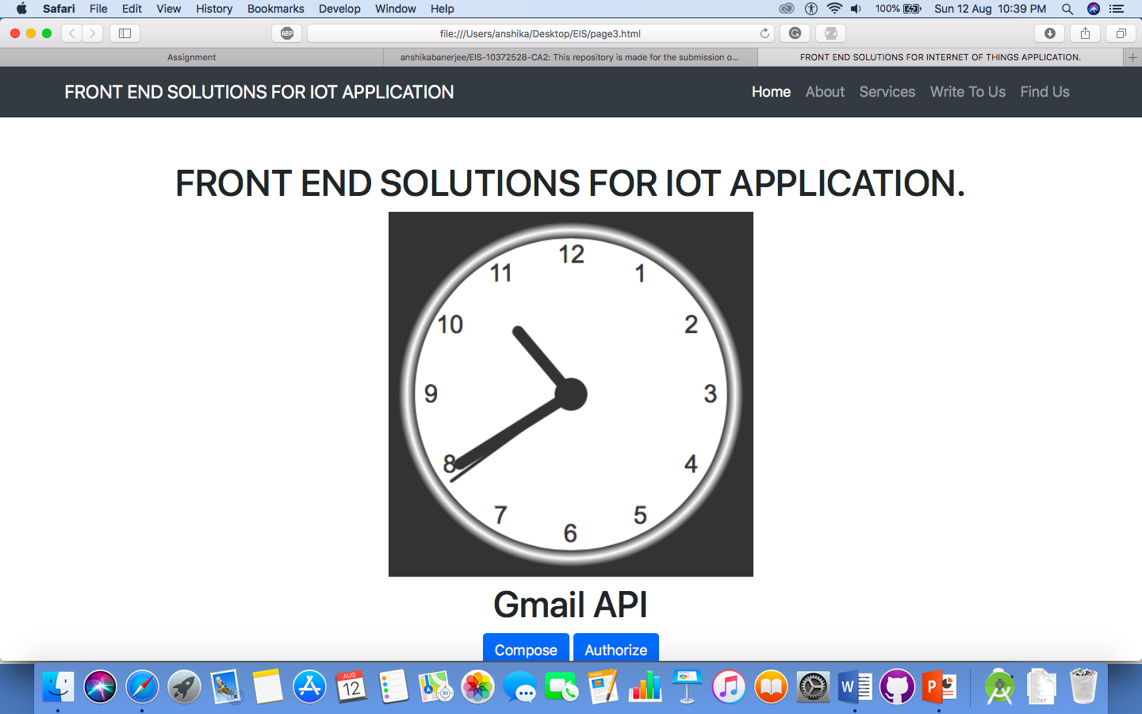

Gmail API

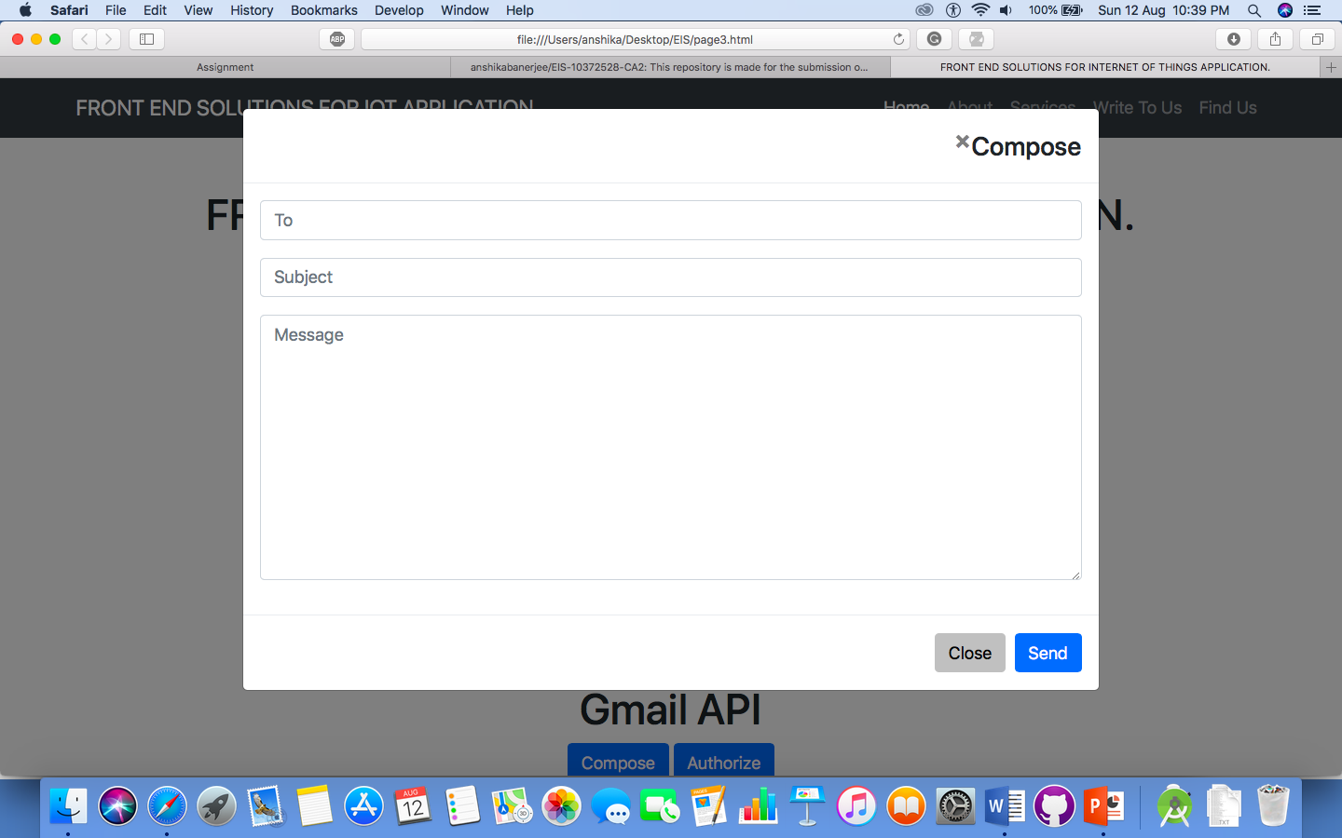

# Conclusion

Thus, all the criteria of the Assignment are fulfilled and the artefact is completed. There has been the delivery of an artefact which provide webservices and uses web services as well. It also makes it a secure experience for the user by providing an oauth authentication system.

# References

* *Gas Sensor - ThingSpeak IoT* (no date). Available at: https://thingspeak.com/channels/182328 (Accessed: 22 June 2018).
* *Große internationale Allianz gegen Cyber-Attacken* (no date). Available at: http://www.faz.net/aktuell/wirtschaft/diginomics/grosse-internationale-allianz-gegen- cyber-attacken-15451953-p2.html?printPagedArticle=true#pageIndex_1 (Accessed: 22 June 2018).
* *Neo Home sensor - ThingSpeak IoT* (no date). Available at: https://thingspeak.com/channels/243783 (Accessed: 22 June 2018).
* Nordrum, A. (2016) *Popular Internet of Things Forecast of 50 Billion Devices by 2020 Is Outdated*, *IEEE Spectrum: Technology, Engineering, and Science News*. Available at: https://spectrum.ieee.org/tech-talk/telecom/internet/popular-internet-of-things-forecast- of-50-billion-devices-by-2020-is-outdated (Accessed: 22 June 2018).
* *OAuth: Pros and Cons of OAuth | Social Technology Review* (no date). Available at: http://www.socialtechnologyreview.com/articles/oauth-pros-and-cons-oauth (Accessed: 22 June 2018).
* ‘Progressive web apps: key benefits, statistics, use cases’ (2017) *Apiumhub*, 14 September. Available at: https://apiumhub.com/tech-blog-barcelona/progressive-web-apps/ (Accessed: 22 June 2018).
* *Twitter PostThing - ThingSpeak IoT* (no date). Available at: https://thingspeak.com/channels/75470 (Accessed: 22 June 2018).